DAY 6 – REPORTS, DASHBOARDS & BDD (XRAY)
1. Xray Reports
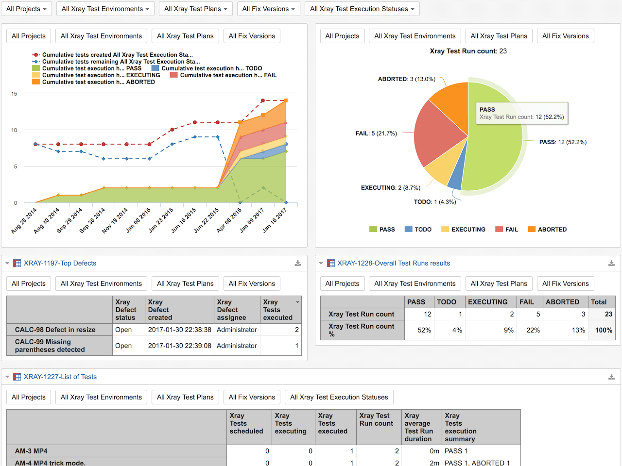
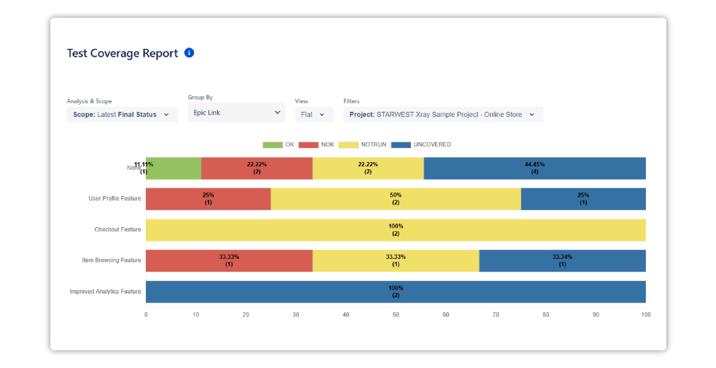
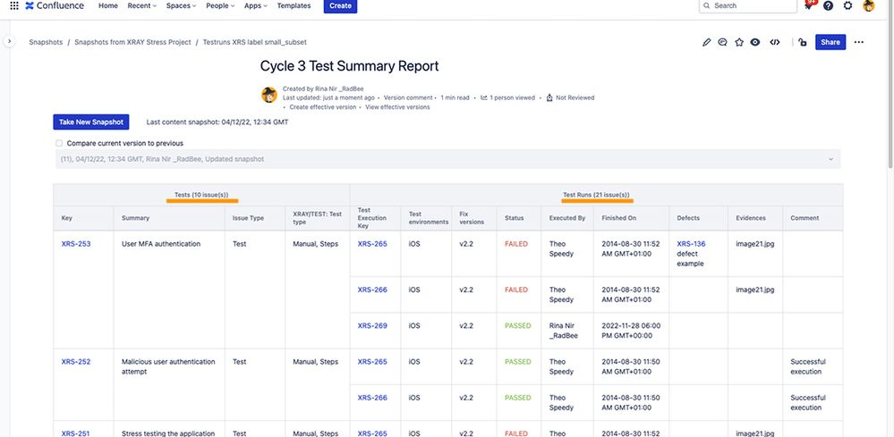
In Xray Test Management, reports convert raw testing data into decision-ready insights.

1.1 Execution Report
Shows what was executed and the outcome.
Includes:
- Pass / Fail / Blocked counts
- Execution progress
- Failed tests list
Used by: QA Leads, Developers
Purpose: Release readiness & defect focus
📌 Hands-on
- Go to Xray → Reports
- Select Test Execution Report
- Choose a Test Execution
- Generate report

1.2 Coverage Report
Shows which requirements are tested.
Includes:
- Covered vs uncovered stories
- Coverage percentage
- Missing tests
Used by: Managers, Product Owners
Purpose: Ensure nothing is missed
📌 Hands-on
- Xray → Reports
- Select Coverage Report
- Choose Project / Fix Version
- Generate

1.3 Traceability Report
Shows end-to-end linkage.
Flow:
Requirement → Test → Execution → Defect
Used by: Auditors, Managers
Purpose: Compliance & accountability
📌 Hands-on
- Generate Traceability Report
- Verify complete links

2. Dashboards
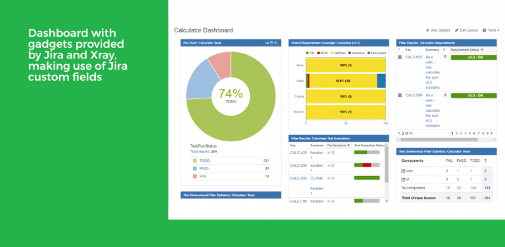
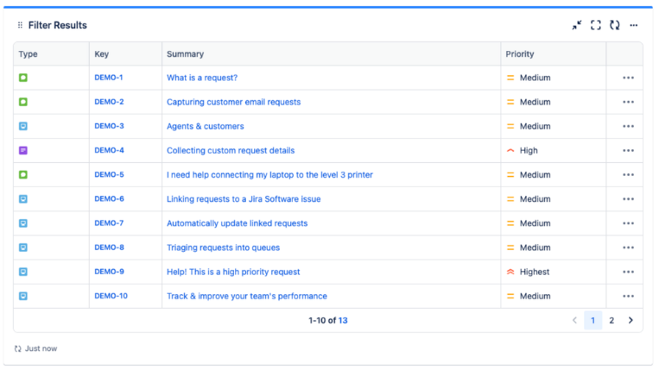
Dashboards provide real-time quality visibility.

2.1 Xray Gadgets
Common gadgets:
- Test Execution Progress
- Test Coverage Gadget
- Requirement Coverage
📌 Hands-on
- Go to Dashboards → Create Dashboard
- Click Add Gadget
- Select Xray gadget
- Configure project & filters

2.2 Jira Filters
Filters help slice data using JQL (Jira Query Language).
Example JQL:
issuetype = Test AND project = QA AND status != Done
📌 Hands-on
- Go to Issues → Search
- Write JQL
- Save filter
- Use it in dashboard gadget

2.3 Dashboard Sharing
- Share with team
- Share with management
- Restrict access if needed
📌 Best Practice:
One dashboard per role (QA, Dev, Manager).

3. Quality Metrics
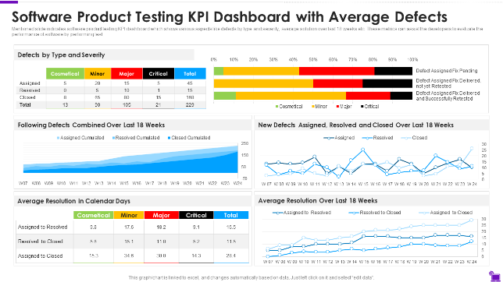

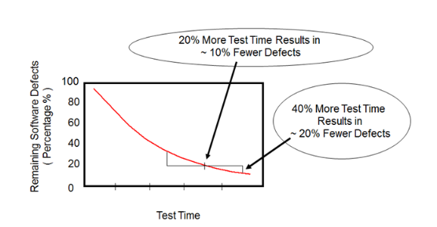

3.1 Pass Percentage
Pass % = (Passed Tests / Executed Tests) × 100
📌 Indicates test stability.

3.2 Fail Rate
Fail Rate = (Failed Tests / Executed Tests) × 100
📌 Indicates defect density.

3.3 Defect Leakage
Defects found after release.
📌 Lower leakage = better testing.

3.4 Test Effectiveness
Effectiveness = Defects found by testing / Total defects
📌 Measures QA impact.

4. BDD with Xray
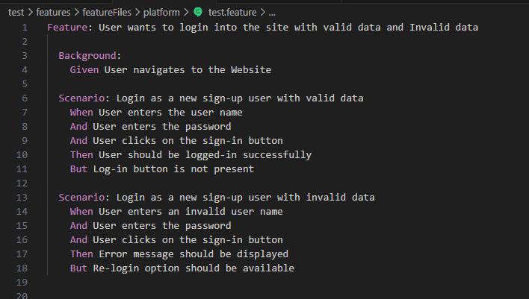
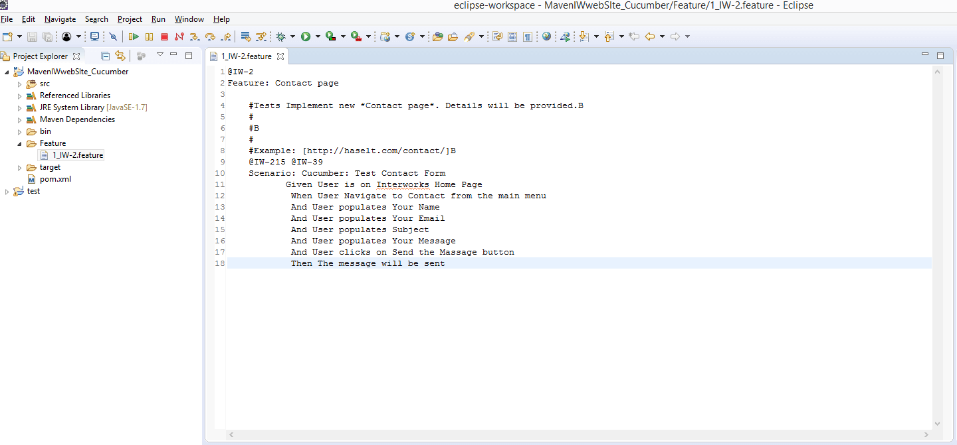
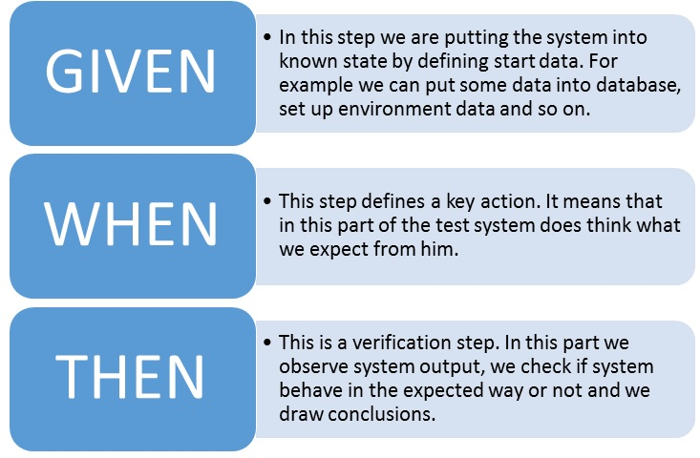

4.1 BDD Overview
BDD (Behavior-Driven Development) focuses on business behavior, not technical steps.
Why BDD?
- Business-readable tests
- Better collaboration
- Automation-ready

4.2 Gherkin Syntax
Gherkin uses simple keywords:
Feature: Login functionality

Scenario: Valid user login
Given user is on login page
When user enters valid credentials
Then user should see dashboard

4.3 Feature & Scenario
- Feature: High-level behavior
- Scenario: Specific example
- Given–When–Then: Context → Action → Result

4.4 BDD in Xray
Xray supports:
- Cucumber tests
- Feature file upload
- Automation result import
📌 Used in CI/CD pipelines.

5. Hands-on Lab (Mandatory)
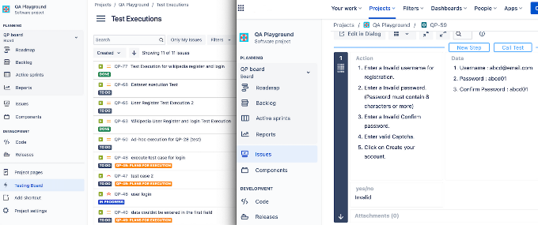

🔹 Task 1: Generate Reports
- Create:
  - Execution Report
  - Coverage Report
  - Traceability Report

🔹 Task 2: Build Dashboard
- Create new dashboard
- Add:
  - Xray Test Execution Gadget
  - Jira Filter Gadget
- Share with team

🔹 Task 3: Create BDD Test
- Create Issue → Test
- Set Test Type → Cucumber
- Add Gherkin scenario
- Save test

🔹 Task 4: Explore Automation Samples
- Open sample Cucumber tests
- Review feature files
- Observe execution results import

6. Summary
Day 6 focused on reporting, dashboards, quality metrics, and BDD.
By completing this day, learners can:
- Convert testing data into insights
- Build real-time dashboards
- Track meaningful quality metrics
- Understand BDD and automation-ready testing

